Steps to Execute Scripts Using CAFT

- Open framework parent folder(i.e. CAFT)
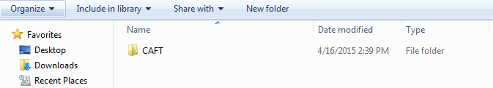
- Open Run Manager Excel sheet(Setting needed to be done before execution of scripts):
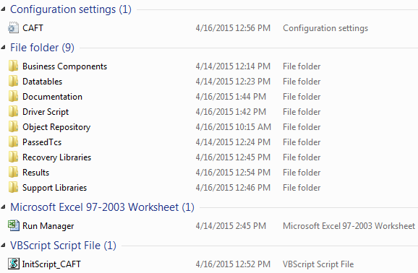
3. Mark ‘Execute’ column as TRUE or FALSE. TRUE-to execute and FALSE-to exempt from execution.
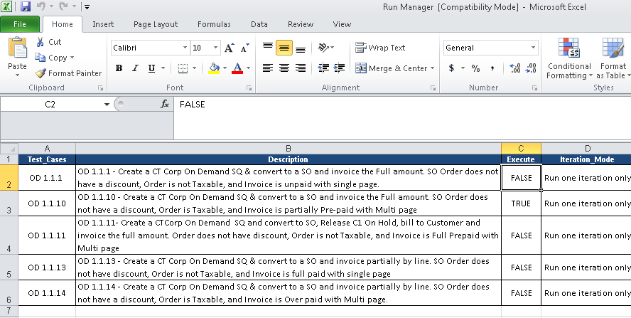
4. Save and close the document:

5. Double click on InitScript_CAFT.vbs file to start execution.
6. QTP/UFT will open in the windows tool bar confirms the start of execution:
7. Analyze the complete result by clicking on TC1_OD link:
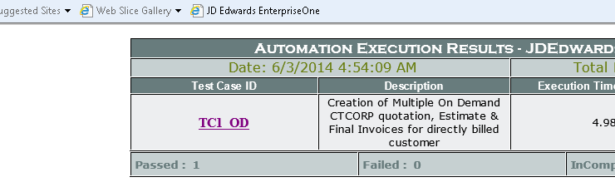

8. Analyze the result:
